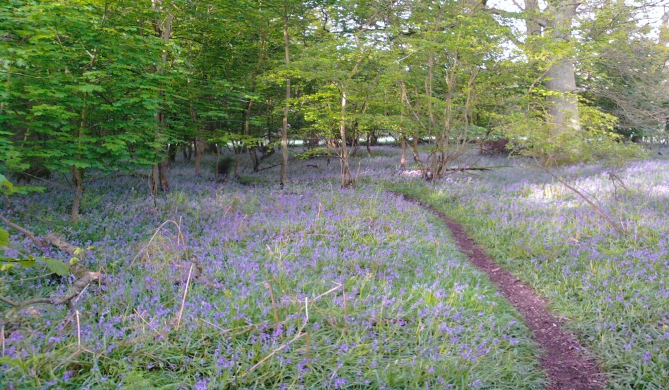
FOLLOW THE COUNTRY CODE

Be safe—plan ahead and follow any signs. Leave gates and property as you find them.
Protect plants and animals and take your litter home.
Keep dogs under close control.
Consider other people.
Know you rights and responsibilities.
For the full countryside code and further information visit www.countrysideaccess.gov.uk

Walking is a safe and healthy form of exercise. Always wear appropriate footwear and take care when walking in the town or countryside.

There is a regular bus served between Hermitage and Newbury. Details from New- bury Buses on 01635 567500 or visit www.hermitagevillage.com.
No responsibility is accepted by the authors of this leaflet for the condition of the paths listed within.
Please use the car parks provided by Eling Estate and shown on the leaflet map. Please do not park in the village hall car park without obtaining prior permission.
More information can be obtained from Hermitage Parish Council.
Acknowledgements
Text by Dick Greenaway, Nick Hopton and Rob Burgess Printing funded by Eling Estate
©Hermitage Parish Council
©West Berkshire Council 2014
© Ann Beard
HERMITAGE
Footpaths, Bridleways and Byways

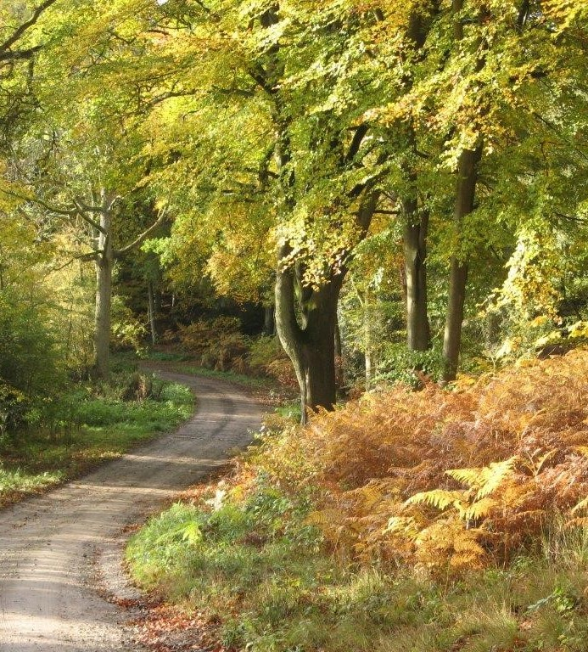

Hermitage Parish lies in the North Wessex Downs Area of Outstanding Natural Beauty

Further copies of this leaflet may be downloaded from www.hermitagevillage.com

Hermitage Parish Council

FOOTPATHS, BRIDLEWAYS AND BY- WAYS OF HERMITAGE
NATURAL HISTORY

THE HISTORY OF HERMITAGE

Hermitage lies some four miles (six kilometers) NNE of Newbury and, like so much of West Berk- shire, is in the North Wessex Downs Area of Outstanding Natural Beauty.

The village lies in a shallow valley on the dip slope of the Berkshire Downs. The parish is mainly woodland with small fields around the perimeter. There are two pubs, one shop with a post office and one butcher.

The path network consists of 23 paths of various classifications and many links to other parish networks. The paths offer walks and rides over differing terrains such as ancient woodlands, old coppices, across fields and along ancient drove roads.

Paths with red names have obstacles such as stiles or steep hills which make them unsuitable for disabled people.

Those with black names have no obstacles but may have uneven and muddy surfaces.

Those with blue names have no obstacles and
have reasonably sound surfaces.

For more information on the wider network see Ordnance Survey Explorer map 158 (Newbury and Hungerford) which shows all public rights of way.

Local parishioners provided the route infor- mation. Eling Estate allows many of its paths to be used by walkers. There are maps in their car parks and the paths are shown on the map page in green. They are unclassified and walkers use them at their own risk.

The maps and the compilation of this leaflet were done by volunteers from Hermitage and the West Berkshire Countryside Society.
The underlying geology is chalk overlain with soils containing clays and flints on the higher ground and alluvial soils and sands in the valley bottom.

Fence Wood, Meetinghouse Wood and Roe- buck Wood are shown on maps of 1761 and are likely to be ancient semi-natural woodlands (woods that existed before 1600). Meeting- house and Roebuck woods were separated by a common in 1761 and there was another com- mon just north of Red Shute Hill.

Hermitage’s woods are rich in bird life and deer
- mainly muntjac and roe - are regularly seen. Many of the paths have interest all year round with abundant spring flowers (please do not pick, it is illegal) beautiful trees and autumn colours, butterflies and far reaching views.

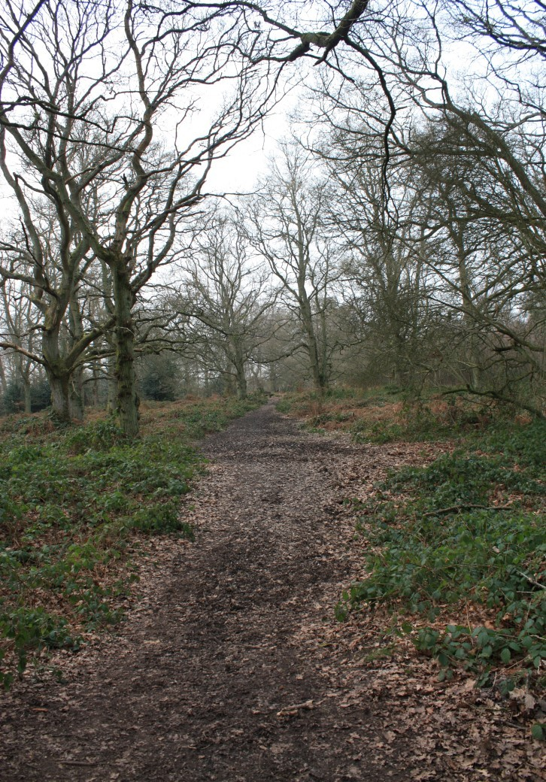
There has been settlement in the parish of Hermitage for thousands of years with the remains of earthworks from an Iron Age hill fort to be seen at Grimsbury castle and evidence of Roman settlement, particularly a villa at Wellhouse and Roman artefacts found at Birch Farm and the vicinity of Doc- tors Lane.

It is likely that three Roman routes ran to and from Grimsbury and later the Faircross area of the parish formed the crossing point of two ancient drove routes, Old Street and Long Lane. The Faircross Hun- dred was first recorded in 1256 and there is legend of dubious authenticity that Her- mitage was named after a holy hermit who lived in the area.

A map of 1761 shows most of the parish as rough ground and just a scattering of hous- es around the junctions of Marlston Road and Yattendon Road with what is now the B4009; indeed the road layout has not changed radically since that time.

The parish was formerly the southern ex- tremity of Hampstead Norreys parish but became a separate parish in 1840 bringing together the settlements of Hermitage, Wellhouse and Little Hungerford.

This was shortly after Adelaide Chapel - named after Queen Adelaide, wife of Wil- liam IV - was built. There have been nu- merous additions to the original small chapel, now Holy Trinity Church, including the Adelaide room.

The first major growth of the population occurred when the Didcot, Newbury and Southampton (DNS) Railway reached the village in 1882.

Hermitage station served the south and
Pinewood Halt, built where the Scout hut and Pinewood playground now stand, served Little Hungerford to the north.

The railway boosted local industry, partic- ularly the Pinewood Brick and Tile Compa- ny which, at its peak, produced up to
50.000 bricks and tiles a week.

This population growth meant a new school had to be built at the north end of the village. It opened in 1913 replacing the old Victorian school which was on a site in the centre of the village that later was used for the village hall.

The railway was especially important dur- ing the Second World War when large amounts of war material were transferred from the Midlands to south coast ports, particularly in the build up to D-Day. At this time a large store for essential sup- plies was built next to the station.

In preparation for D-Day a US Army hospi- tal was built in the village for casualties of the invasion. This later became a camp for Polish refugees and eventually, in 1949, became the School of Military Survey.

After the war traffic on the railway de- clined the DNS became a victim of the Beeching Plan and closed in 1964.

The M4 opened in 1971 and Hermitage was now part of the commuter belt. This resulted in rapid growth with new housing developments such as Lipscombe Close and Dines Way in the 1980s.

More recently, in this century, there have been developments at the southern end of the village—Hermitage Green—and, at the northern end where Forest Edge is built on the former site of Pinewood Brickworks.

WALK DESCRIPTIONS

Footpath 14 comes from Oare. Look for the old coppice stools on the boundary bank showing that the bank is ancient. This was once common grazing and the artificial ponds provided water for animals. The large banks and ditches are part of ancient enclosures.

Footpath 15 runs through Common Firs wood to join paths 11 and 12.

Footpath 16 runs from Yattendon Road along- side the old railway (closed in 1964) to Marlston Road It is well surfaced and passable in most weather.

Note the large ash and sycamore stools on the embankment—the result of regular cutting in the steam train era.

Footpath 17 rises up a steep slope from the B4009. In 1761 the whole of this area was open common land. There are many species of birds and deer are often seen.

Footpath 18 leaves the Yattendon Road and runs along the boundary of Chalk Pit Piece to a field with hollows and humps from old brick earth or sand quarries.

These continue in Furze Hill Wood. Some are very deep and contain ponds. The highest point to the south is the site of a windmill moved to Compton in 1760. In 1761 all this area was open scrub land. There are stiles.

Footpath 19 links path 2 to the Yattendon Road and runs through conifer plantations which smell wonderful in warm weather There are yet more quarry pits in the woods.

Footpath 20 leads from Doctor’s Lane diagonal- ly across the field to Spring Copse. There are two stiles.
Look for bluebells in spring and some very an- cient coppice stools. The old pit probably sup- plied sand to make bricks at Kiln Farm. The wet area near the top of the hill is caused by the springs that named the wood.

Footpath 21 joins paths 7 and 9.

Number 22 is not in use so not marked.

Footpath 23 begins at Doctor’s Lane, named because it led to the doctor’s surgery. It has the same name on an 1877 map suggesting Her- mitage had a resident doctor earlier than most villages.

Note the pressure marks, glazing and colour variations in the brick wall and the small sarsen stone which may possibly be a boundary mark. Hermitage House is dated 1715. Note the sand pit at the parish boundary.

Footpath 24 rises up a steep slope from the B4009 onto the old Common where it joins path 14 near a pond. The soils are sands and so the pond must be lined with clay.

Footpath 25 is shared with Frilsham as ‘Frilsham 13’. The parish boundary runs along the centre of the path indicating great antiqui- ty. It may have been established by the 9th century.

Note how deeply it is sunk. There are deep quarries in the wood and excellent views to the east.

The Furze Hill open space path runs from the Forest Edge Estate along the old railway through the very species rich butterfly meadow and Furze Hill wood to path 18. There are other paths through the public open space but the map scale does not allow them to be shown.
Restricted Byway 1 (Fence Lane) This is a very ancient drove route connecting the Ridgeway with Bucklebury Common via Old Street. It prob- ably pre-dates Grimsbury Castle which is an Iron Age hill fort.

The high banks allowed a large number of ani- mals to be driven by a few men with dogs. The woodland plants such as bluebells and wood anemones on the banks indicate that they were built through ancient woodland. The rich ground flora in Fence Wood shows that this is ancient semi-natural woodland.

Look for the conical quarry pit on the east of the lane. Look out for buzzards and red kites.

Restricted Byway 2 This wide track is on an an- cient road that ran north across the open land to Bothamstead Green and south to Bucklebury Common. It is often very muddy.

Look for quarries at a number of places beside the track. Wellhouse Farm at the southern end is late 18th century in origin but is on the site of an older settlement. Look for an ancient stub oak on the bank near Wellhouse Farm.

Footpath 3 runs across the field from a stile on Yattendon Road to a gate at Birch Cottage.

Number 4 is not marked as no longer used.

Footpath 5 runs north from Wellhouse Lane entering the parish after about 350 metres. The boundary is marked by a wide ditch in the wood to the north.

This path is an ancient road which leads from Bucklebury to open land. Look for the oak lined banks.

Footpath 6 runs from path 5 to Box Cottage, formerly on the edge of the open land. Look for the oak lined banks.
Byway 7 continues path 2 to the south from Wellhouse Farm to Marlston Road. There are yet more quarry pits on either side.

Byway 8 continues path 9 to the north from Marlston Road to Wellhouse Lane. The house at the Marlston Road end was a shop in the early 20th century.

Byway 9 The original barn and the granary raised on staddle stones (stone mushrooms) were retained.

Look for the sheds built in railway style and the tall chimney in the distance. This was part of a steam driven pump which drew water from a 24m (80ft) deep well and fed it around the es- tate. The pump house also housed the laundry.

Byway 10 runs NE from the southern end of path 1 for 40m along the parish boundary. Look for snowdrops in spring.

Restricted Byway 11 is metalled from Yatten- don Road at the M4 bridge to the mobile phone mast. Rooks Copse is Ancient Woodland and very species rich.

Look for dog’s mercury , bluebell, celandine, violets, moschatel, ramsons, wood anemone, wood sorrel and many more plants.

Footpath 12 runs NE between stiles across the field from path 2 to a beautiful little valley with wooded slopes. The low banks crossing the path are part of an ancient field system.

Footpath 13 leaves the B4009 near the school and runs to the parish boundary near an old sand pit. This pit probably acts as a swallow hole where surface water enters the underground aquifers. It is valuable wetland for wildlife.

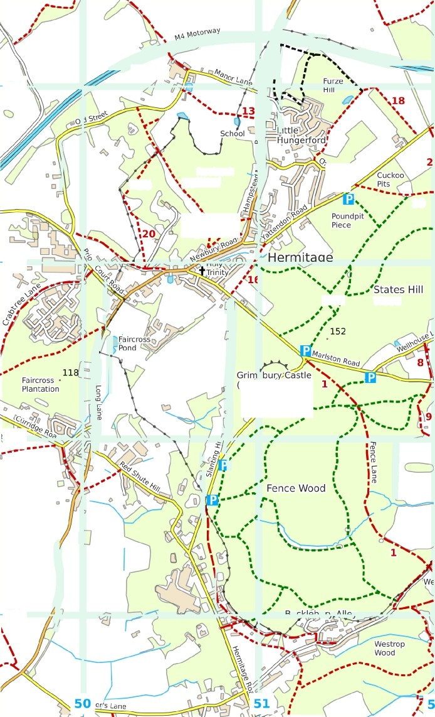
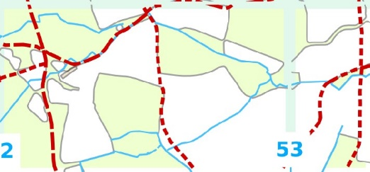
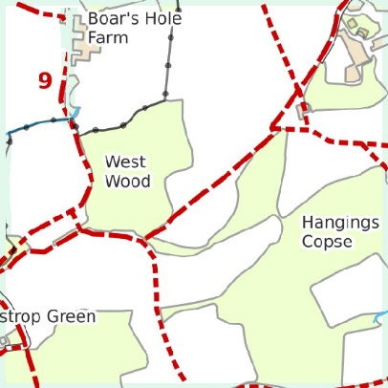
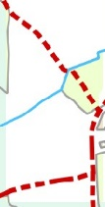
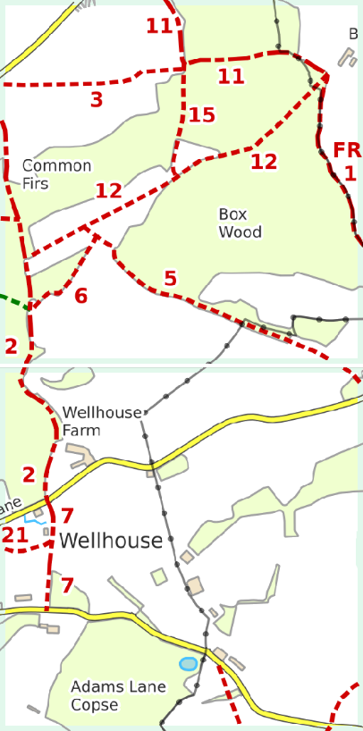
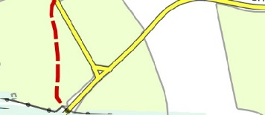
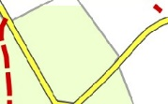
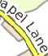
HERMITAGE PARISH PATHS

Oare
74

Roebuck
. 20 L4 Wood
”

ch Fa rm

L

*t*'** l4j *?:

73

n ,’ Wood

Fort

72
Brockhurst School

71

Rights of way data derived in part Tram Ordnance Survey mapping. Crown Copyright. Licence 10003633S.

Observe the Country Code at all times.

0 250

500 750 1000
METRES

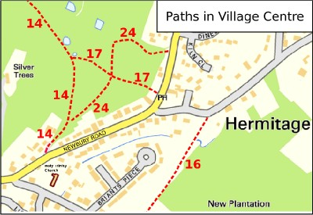
Car park
ELING ESTATE - PATHS IN HERMITAGE WOODS
Car parking is provided by the Eling EsEaEe.
LV Users park at their own risk.
Public access is permitted on foot to all of the paths in the woods. Minor paths in the woods are not shown on this map.

Horse riding is not permitted without permission from the Estate office. Telephone 01635 20026B

Do not disturb wildlife or other visitors, keep dogs under close control, do nothing that might ca use fires and take your litter home with you.

The following are prohibited in the woods: bicycles, motorcycles, vehicles of any sort, fi rearms.
Parish boundary
Rights of way
- - - - - - Footpath
——— Bridleway
---- Restricted byway
-- -- Byway open to all traffic Other paths
- - - - -- Open space path
- - - - - - Eling Estate path

